Snakes and Ladders: Profiling Data

# 2 Players

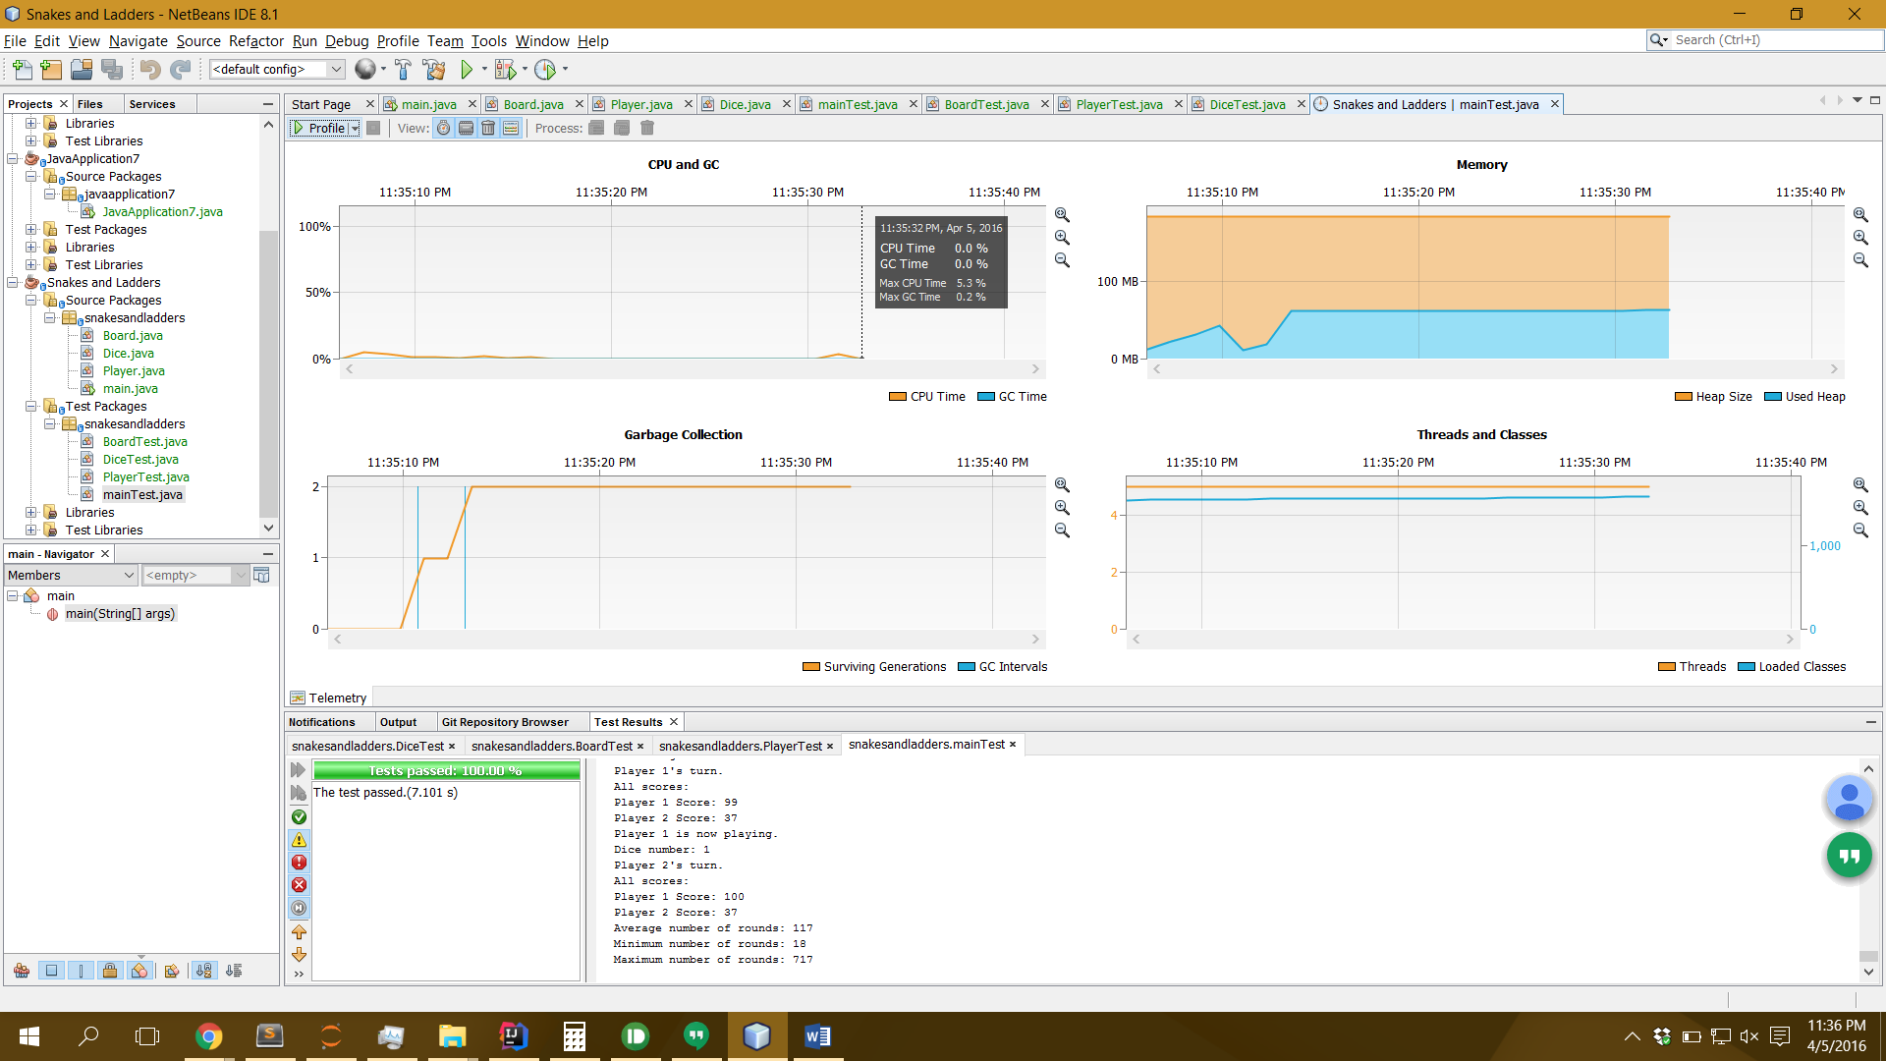

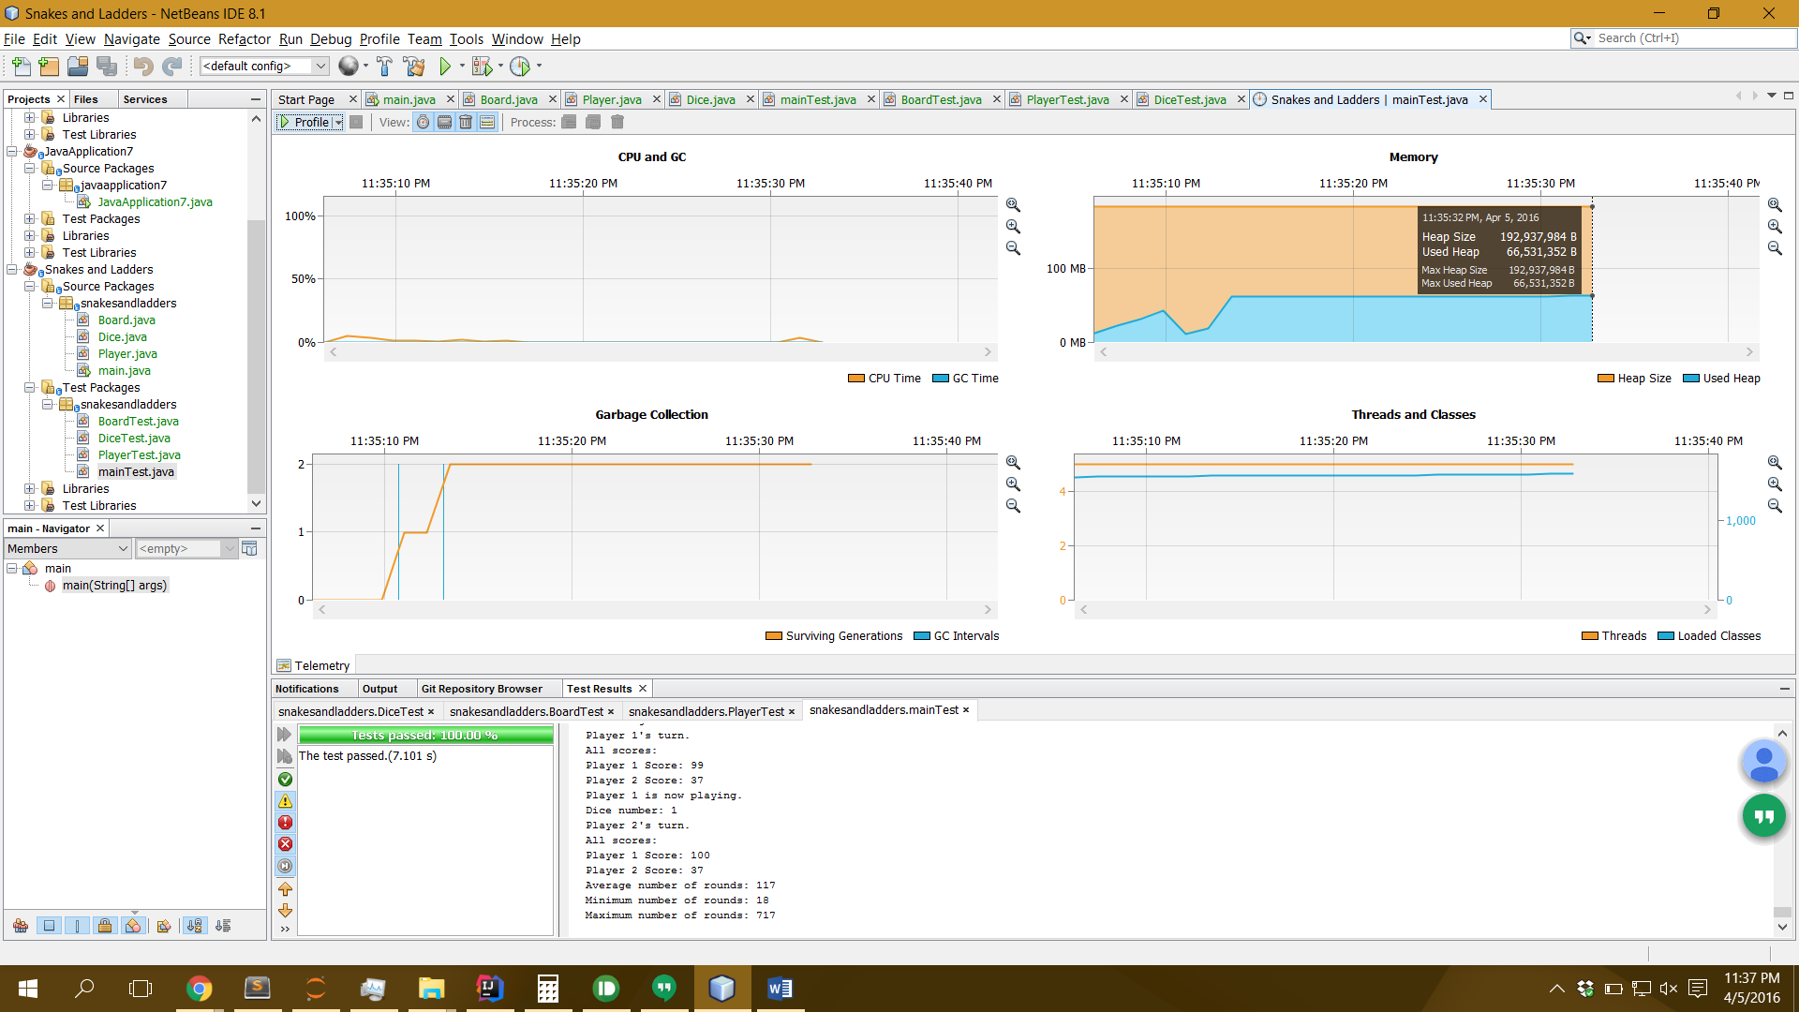

# 4 Players

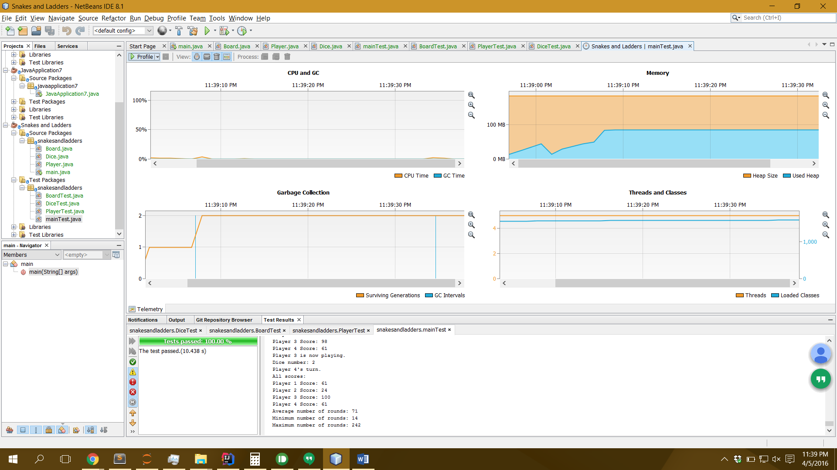



# Random Number of Players (between 2 and 4 inclusive)

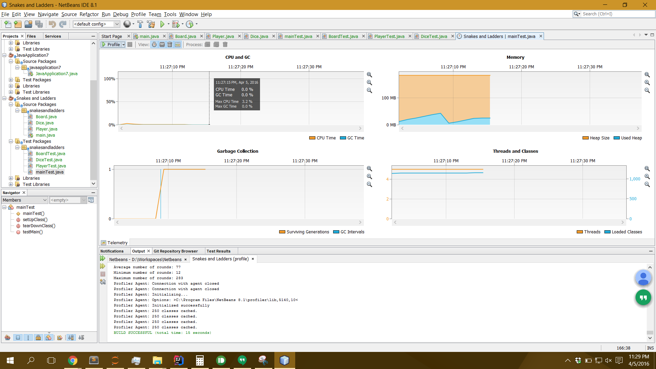

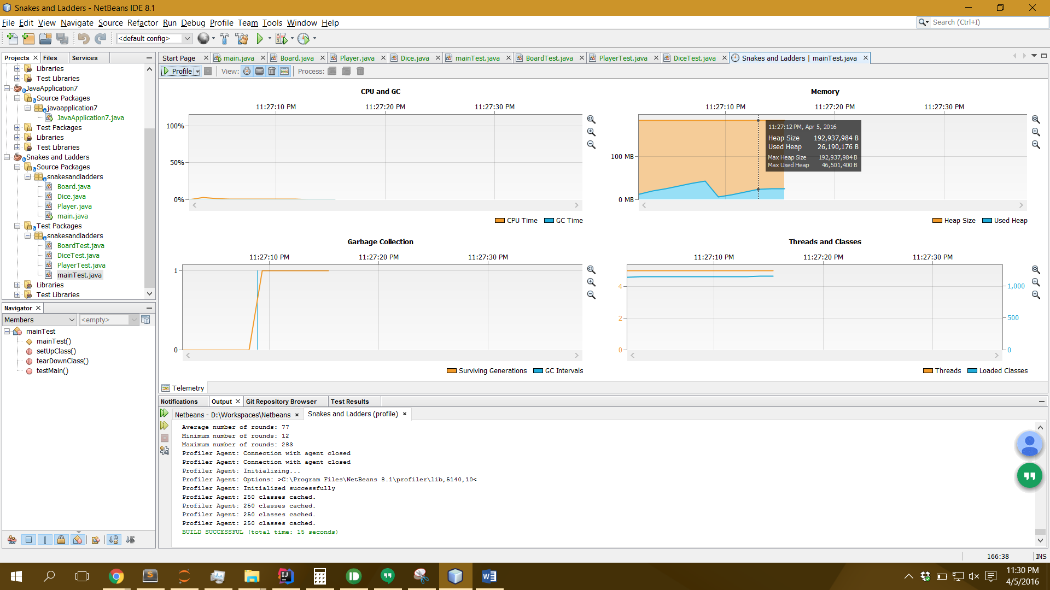

# Analysis

The CPU seems take the most time when there are 2 players.

The memory seems to be used the most when there are 4 players.

The high memory usage may be because of the sheer amount of console output (multiple outputs per player). The high CPU usage for least players is perplexing.